Application Form
Full name of application company
Address of application company
Bank name |  |  |  | Bank account
Type of network application | □ Distributor □ Service Supplier □ Spare Parts Center
Shareholder Information | Name of shareholder
 | Share proportion
Management information | Job title
 | full name
Information about application company |  |  |  |  |  | Yes/ no
Annex I | Company profile |  |  |  |  | □ yes | □ no
Annex II | Business license |  |  |  |  | □ yes | □ no
Annex III | financial statements |  |  |  |  | □ yes | □ no
Annex 4 | Business outlets |  |  |  |  | □ yes | □ no
Annex V | Business plan |  |  |  |  | □ yes | □ no
Commitment of application company | The materials provided by the company and the information and data therein are true. The applicant shall be fully responsible for all consequences caused by the untrue materials.  Signature of applicant company:
Audit department | Audit opinion |  |  |  |  | Audit date
Business representative
Regional Manager
network administrator
Director of Network Management
Instructions for application form:
1- Full name of application company: full name of the company in English or local language.Indonesia Pt, Latin America S.A. and other local abbreviations are excluded
2- Registered company address: accurate to the house number, Google maps can search location
3- Bank information: the most commonly used bank name, account number.It is used to settle claims and other businesses.
4- Information of shareholders: arranged according to the shareholding proportion.
5- Management information: main business responsible persons, such as general manager, purchasing person in charge, sales person in charge, after-sales person in charge, etc.
6- Financial statements: financial statements of recent three years.
7- Company profile: including the history, organizational structure, business scope and recent business performance of the applicant company
8- Business outlets: fill in the relevant information of all business outlets according to the table of business outlets, including self operated and cooperative outlets.
9- Business plan:
For the application of dealers, it should include but not limited to the cooperation period (generally 3-5 years), the underwriting sales target during the cooperation period, the underwriting model, network channel development, promotion activities and other plans.
For the application service supplier, it should include but not limited to the cooperation period (generally 3-5 years), service man hour standard, spare parts compensation rate standard and network channel development during the cooperation period.
For the application of spare parts center, it should include but not limited to the cooperation period (generally 3-5 years), the guiding price of spare parts supply to distributors and service suppliers, and the development of network channels during the cooperation period.

Information of business outlets
Branch name | (one page for each branch)
Address of branch | (Google maps can search and locate)
Nature of outlets | □ Self-owned  □ Cooperation (cooperation period: to month/year.  cooperation agreement □ )
Network type | □ Sales □Service □ Spareparts
Person in charge of outlets | full name | contact information | Number of business personnel
area |  | Wide frontage |  | Floor height
1.Front photo of the appearance of the proposed storefront  example |  |  | 2.45 ° photo on the right side of the proposed storefront  example
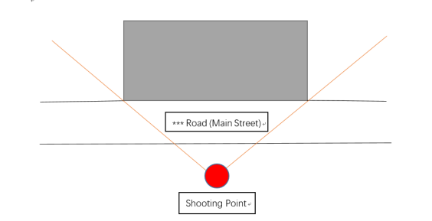  example |  |  | 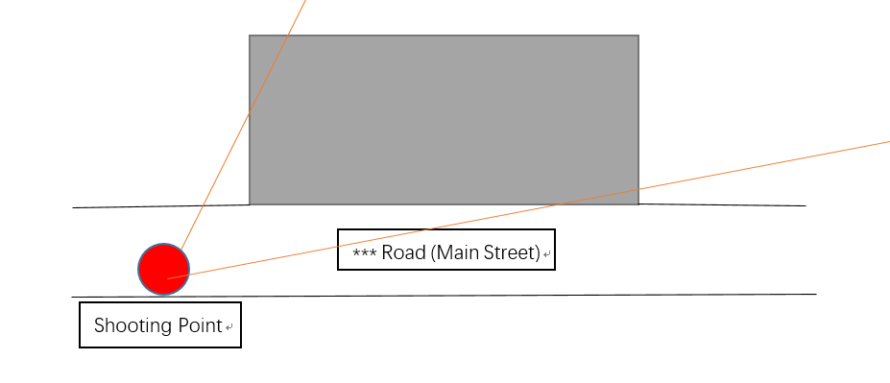  example
3.45 ° photo on the left side of the proposed store site |  |  | 4.Photos of the interior of the proposed storefront
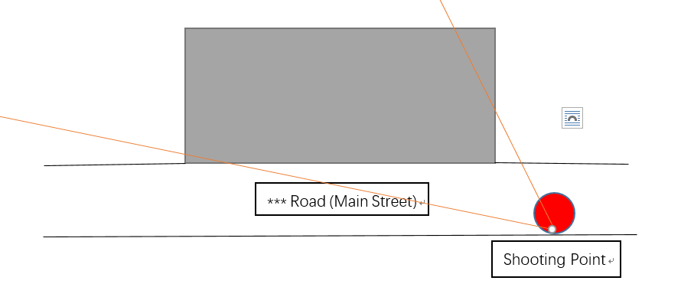  example |  |  | 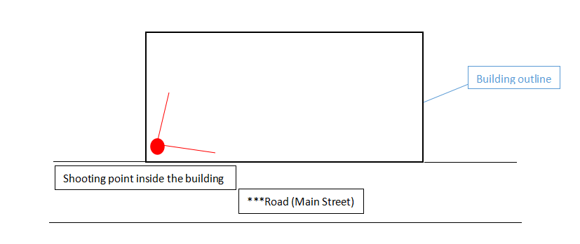  example
5.Photos of the interior of the proposed storefront |  |  | 6.Photos of the interior of the proposed site
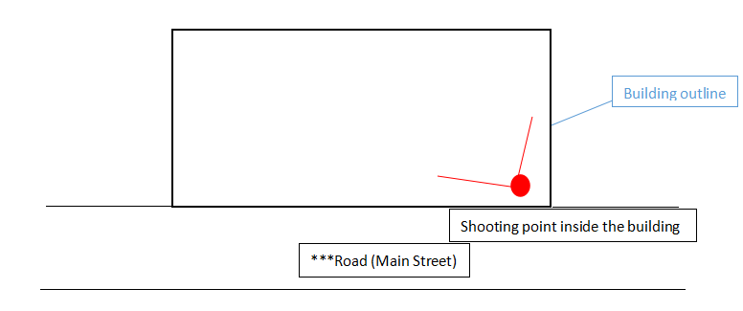 |  |  | 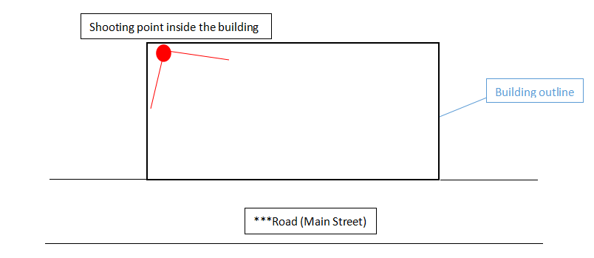
7. photos of the interior of the proposed storefront |  |  | 8.Layout plan of the proposed site (hand drawn is also ok)
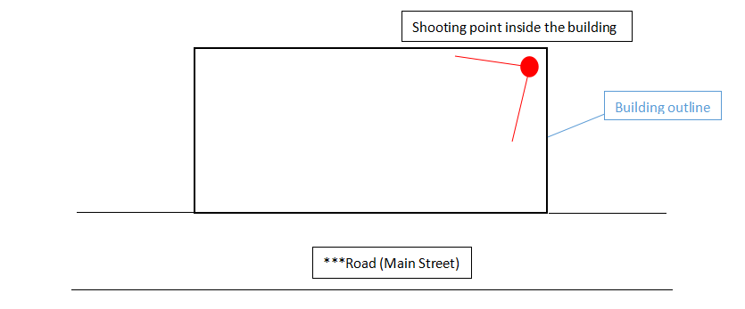  example |  |  | 